CSS3
- Developed by Hakon Wium Lie in 1994.
- CSSCascading Style Sheet
- If HTML is the structure of the web page then CSS is the look and style of the web page.
- It's the language to make our web page presentable.
- Desinged to make style sheets for web.
Now let's try to break the acronyms:
- Cascading-->Falling of styles
- Style-->Adding designs/styling our HTML tags
- Sheets-->writing our style in different documents.
History of CSS:
- 1994First proposed by Hakon Wium Lie on 10th oct.
- 1996It was published 17th nov with influencer Bert Bos and later he became co-author of CSS.
- 1996CSS became official with CSS was published in Dec.
- 1997created CSS level 2 on 4th nov
- 1998published on 12th May
CSS Editors:
- Visual studio code
- Sublime text
- Notepad++(Great for HTML & CSS)
- Atom
- Brackets
- Espresso(Mac ios user)
- Komodo Edit(Simple)
CSS Basic Structure/syntax:
selector
{
property1:value;
property2:value;
property3:value;
....
}
- Selectorselects the element you want to target
- There are few basic selectors like tags,id's,classes.
- All forms this key-value pair.
- Keysproperties(attributes) like color,bgc,bgi,bg,font-size,width,height,...
- Valuesvalues associated with these properties.
- Always remains same whether we apply internal or external styling.
Css Comments:
- It don't render on the browser.
- Helps to understand our code better and make it readable.
- Helps to debugging our code.
- Two ways to comment:
  - Single line
  - Multi line
- Both starts from /* and ends with */ctrl+/
Css types/Different ways to write CSS:
- There are 3 ways to write Css in out HTML file.
  - Inline Css
  - Internal Css
  - External Css
- Priority order: Inline Internal External
Difference between inline , internal and external CSS:
Inline | Internal | External
By using style attribute inside the html elements | By using a style attribute in the head section | Used to add link to it in the <head> section.
Lot a redundancy,  and uniquely applied on each element. | Here, redundancy is removed and uniquely applied on single document. | Here, redundancy is removed and uniquely applied on each document.
Idea of separation of concerns was lost. | But idea of separation of concerns still lost. | Idea of separation of concerns is maintained.
Before Css this was the only way to apply styles. | With the help of style tag we can apply styles within the Html file. | With the help of <link> tag in head tag we can apply styles.
ex:<marquee style="color:blueviolet; text-align: center;">hi</marquee> | <head>  <style>  marquee  {  color:aqua;  }  </style>  </head> | syntax:  <link rel="stylesheet" href="st.css">

Priority Based example:
<!DOCTYPE html>
<html lang="en">
<head>
<meta charset="UTF-8">
<meta name="viewport" content="width=device-width, initial-scale=1.0">
<title>Document</title>
<link rel="stylesheet" href="y.css">
<style>
h1
{
color: green;
}
</style>
</head>
<body>
<h1 style="color: red;">Yoga</h1>
</body>
</html>

CSS Selectors:
- Selectors are used target elements and apply Css.
- Three simple selectors:
- Element selector
- Id selector
- Class selector
- Priority of Selectors: ID Class Element
Element Selector | ID Selector | Class Selector
Used to select HTML elements by its name | Id attribute is used to select HTML element.  Used to target specific or unique element. | Class attribute is used to select HTML element.  Used to target specific class of element
Ex:  h1  {  color:brown  } | Ex:  #unique  {  color:red  }  <p id="unique">Hi</p> | Ex:  .group  {  color:red  }  <p class="group">Hi</p>

- Universal Selector:
  - Wild card character.
  - Used to target specific all the elements
  - Ex:
*
{
color:blue
}
<h1>Hi</h1>
<h2>Hello</h2>
- Group Selector:
  - It minimizes code.
  - Used to target specific group of elements
  - Ex:
h1,h2
{
color:blue
}
<h1>Hello</h1>
<p>Hi</p>
<h2>Hello</h2>
- Pseudo-class Selector (mouse over action):
- used to target state of element.
- Ex:
p:hover
{
color:blueviolet;
}
<p>Hi</p>
- We selected element and then changed the color property.
CSS color : (CSS Gradient font colors website)
- It is specified with predefined color names, or with RGB,HEX,HSL,RGBA or HSLA
- We can set the background-color, text color, and border color also, etc...
- Some color names are,
- Tomato,orange,Dodgerblue,mediumseagreen,gray,
slateblue, voilet,lightgray.
- RGB (red,green,blue)
- Range between 0 to 255 (256)
256*256*256 16,777,216 possible colors
Red255,0,0
Green0,255,0
Blue0,0,255
rgb(0,0,0) black
rgb(255,255,255) white
- HEX16#rrggbbbetween 00 to ff
Red #ff0000
Green #00ff00
Blue #0000ff
#000000 black
#ffffff white
- HSL(Hue,Saturation,lightness)
- Hue 0 to 360 degree
0red, 120green, 240blue
- Saturation 0% to 100%
0% gray
100% full color
- Lightness 0% to 100%
0% black
100% white
- RGBA or HSLA (red green blue alpha or hue saturation lightness alpha):
- Alpha 0.0 to 1.0
0.0 transparent
1.0 not transparent
CSS Backgrounds:
- The background properties are used to add background effects for elements.
- Background properties are,
- Background - color
- Background - image
- Background - repeat sets how a background img will be repeated
- Background – attachment set whether a background img is fixed or scrolls with the rest of the page.
- Background – position sets the starting position of a background img
- Background (shorthand property)
body
{
/* background-image: url(dog.jpg);
background-repeat: no-repeat;
background-attachment: scroll;
background-position: right; */
background: url(dog.jpg) no-repeat scroll;
background-size: cover;
}

CSS Gradient:
- To display smooth transitions between two or more specified colors.
- CSS defines three types of gradients:
- Linear Gradients (goes down/up/left/right/diagonally)
- Radial Gradients (defined by their center)
- Conic Gradients (rotated around a center point)
- Linear Gradient:
  - To create a linear gradient you must define at least two color stops.
Syntax:
background: linear-gradient(direction, color-stop1, color-stop2, ...);
background-image: linear-gradient(angle, color-stop1, color-stop2);

Radial Gradients:

A radial gradient is defined by its center.

By default, shape is ellipse

Syntax:
background-image: radial-gradient(shape size at position, start-color, ..., last-color);

Conic Gradients:
  - A conic gradient is a gradient with color transitions rotated around a center point.
  - By default, angle is 0deg and position is center.

Syntax:
background-image: conic-gradient([from angle] [at position,] color [degree], color [degree], ...);
<!DOCTYPE html>
<html lang="en">
<head>
<meta charset="UTF-8">
<meta name="viewport" content="width=device-width, initial-scale=1.0">
<title>Document</title>
</head>
<style>
.linear{
background: linear-gradient(rgb(176, 83, 12),white ,green);
height: 200px;
width: 200px;
border-radius: 100px;
}
.Radial{
background: radial-gradient(green,red 20%,white,rgb(255, 113, 5));
height: 200px;
width: 200px;
border-radius: 100px;
}
.conic{
background:conic-gradient(green,white,rgb(176, 83, 12));
height: 250px;
width: 200px;
border-radius: 100px;
}
</style>
<body>
<div class="linear"></div><br><br>
<div class="Radial"></div><br><br>
<div class="conic"></div>
</body>
</html>

CSS Padding and Margin:
- It is used to create space around an element's content, inside of any defined borders.
- It is used to create space around elements, outside of any defined borders
- (same as padding)
- Padding-Individual sides:
- padding-right
- padding-left
- padding-top
- padding-bottom
- padding (shorthand property)
- Ex:
(long hand method)
/* padding-left: 20px; */
/* padding-top: 20px; */
/* padding-bottom: 35px; */
/* padding-right: 45px; */
/*short hand methods*/
padding: 100px; same for all
padding:100px 150px; 1st one top&bottom, 2nd left&right
padding:100px 30px 12px; 1st top, 2nd left&right, 3rd bottom
padding:10px 15px 20px 30px; clock wise(top,right,bottom,left)
CSS height and width:
- width is finite 100%
- height is infinite.
CSS Shadow:
- There are 3 types,
- Text Shadow
- Box Shadow
- Drop Shadow
- Text Shadow:
  - Applying shadows specifically to text elements.
  - Ex:
  - text-shadow: 2px 2px 4px rgba(0, 0, 0, 0.5);
  - Horizontal offset (x-axis): Specifies the horizontal distance of the shadow from the text.
  - Vertical offset (y-axis): Specifies the vertical distance of the shadow from the text.
  - Blur radius: Specifies the blur radius of the shadow. A higher value creates a more blurred shadow.
  - Shadow color: Specifies the color of the shadow.
  - You can use either named colors or specify colors using RGBA or HEX values.
- Box-shadow:
  - It can also take multiple shadows separated by commas to create layered or multiple shadows.
- Drop shadow:
- It creates a shadow of the non-transparent parts of the image.
<!DOCTYPE html>
<html lang="en">
<head>
<meta charset="UTF-8">
<meta name="viewport" content="width=device-width, initial-scale=1.0">
<title>Document</title>
<style>
h1
{
text-shadow: 2px 2px 4px red;
}
h2
{
border: 1px solid;
box-shadow: 5px 5px 10px green;
}
img
{
filter: drop-shadow(5px 10px 12px pink);
}
</style>
</head>
<body>
<h1>Yoga</h1>
<h2>Ravi</h1>
<img src="dog.jpg" alt="">
</body>
</html>

CSS Text:
- CSS has a lot of properties for formatting text.
- Text color Specifies the color of text
- Text Alignment is used to set the horizontal alignment of a text. A text can be left or right aligned, centered, or justified.
- Text Decoration text-decoration-line property is used to add a decoration line to text.
Tip: You can combine more than one value, like overline and underline to display lines both over and under a text.
- Text-transform is used to specify uppercase and lowercase letters in a text. It can be used to turn everything into uppercase or lowercase letters, or capitalize the first letter of each word.
- Text Spacing Properties:
- letter-spacing Specifies the space between characters in a text
- line-height Specifies the line height
- text-indent Specifies the indentation of the first line in a text-block
- white-space Specifies how to handle white-space inside an element
- word-spacing Specifies the space between words in a text
<!DOCTYPE html>
<html lang="en">
<head>
<meta charset="UTF-8">
<meta name="viewport" content="width=device-width, initial-scale=1.0">
<title>Document</title>
<style>
h1
{
color: chartreuse;
text-align: center;
text-decoration-line: underline;
text-decoration-color: brown;
text-transform:capitalize;
letter-spacing: 5px;
word-spacing: 10px;
white-space: 2px;
line-height: 100px;
}
</style>
</head>
<body>
<h1>Yaagul is a std</h1>
</body>
</html>

CSS Fonts:
- To choosing the right font has huge impact on how the readers experience a website.
- Generic Font families:
  - Serif TimesNewRoman
  - Sans-serif Arial, Veranda, Helvetica
  - Monospace Courier
  - Cursive Brush script Mt lucide handwriting
  - Fantasy Copperplate Papyr us
Font properties:
- Font style
- Font size / line-height
- Google font website Select Regular 400 + link within the head section and css for particular tag or element.
- Font variant
- Font family
- Font weight
<!DOCTYPE html>
<html lang="en">
<head>
<meta charset="UTF-8">
<meta name="viewport" content="width=device-width, initial-scale=1.0">
<title>Document</title>
<link rel="preconnect" href="https://fonts.googleapis.com">
<link rel="preconnect" href="https://fonts.gstatic.com" crossorigin>
<link href="https://fonts.googleapis.com/css2?family=Sixtyfour&display=swap" rel="stylesheet">
<style>
h1
{
font-family: 'Sixtyfour', sans-serif;
}
</style>
</head>
<body>
<h1>Ravi shankar</h1>
</body>
</html>

<!DOCTYPE html>
<html lang="en">
<head>
<meta charset="UTF-8">
<meta name="viewport" content="width=device-width, initial-scale=1.0">
<title>Document</title>
<style>
h1
{
/* font-family: cursive;
font-size: 50px;
font-weight:normal;
font-variant: small-caps;
font-style: italic; */

/* short hand property */
font:italic small-caps normal 50px cursive;
}
</style>
</head>
<body>
<h1>Ravi shankar</h1>
</body>
</html>

CSS Links:
- With CSS, links can be styled in many different ways.
Styling Links:
- Links can be styled with any CSS property (e.g. color, font-family, background, etc.).
- In addition, links can be styled differently depending on what state they are in.
- The four links states are:
  - a:link - a normal, unvisited link
  - a:visited - a link the user has visited
  - a:hover - a link when the user mouses over it
  - a:active - a link the moment it is clicked
- When setting the style for several link states, there are some order rules:
  - a:hover MUST come after a:link and a:visited
  - a:active MUST come after a:hover
- The text-decoration property is mostly used to remove underlines from links.
- The background-color property can be used to specify a background color for links.
- The different types of cursors (can be useful for links)
<!DOCTYPE html>
<html lang="en">
<head>
<title>Document</title>
<style>
a
{
text-decoration: none;
background-color: orangered;
color: grey;
font-size: 50px;
}
a:link
{
background-color: purple;
color: pink;
}
a:visited
{
background-color: red;
color: yellow;
}
a:hover
{
background-color: skyblue;
color: lightgreen;
cursor:wait;
}
a:active
{
background-color: white;
color: black;
}
</style>
</head>
<body>
<a href="https://www.facebook.com">Facebook</a>
</body>
</html>

CSS Display:
- The display behavior (the type of rendering box) of an element.
- Default display:none;
Properties:
- Inline
- Block
- Inline-block
- Flex
- Grid
- display: inline;
<!DOCTYPE html>
<html lang="en">
<head>
<meta charset="UTF-8">
<meta name="viewport" content="width=device-width, initial-scale=1.0">
<title>Document</title>
<style>
li
{
display: inline;
}
</style>
</head>
<body>
<ul>
<li>Home</li>
<li>About Us</li>
<li>Services</li>
<li>Contact Us</li>
</ul>
</body>
</html>

- display:block;
<!DOCTYPE html>
<html lang="en">
<head>
<title>Document</title>
<style>
li
{
display: block;
}
</style>
</head>
<body>
<ul>
<li>Home</li>
<li>About Us</li>
<li>Services</li>
<li>Contact Us</li>
</ul>
</body>
</html>

- display:flex; At a time we can align either row or column.
- flex direction row, row reverse, column, column reverse
- flex wrap nowrap,wrap,wrap reverse
- flex flow shorthand property for flex direction & flex wrap
- justify content

- align items & align content
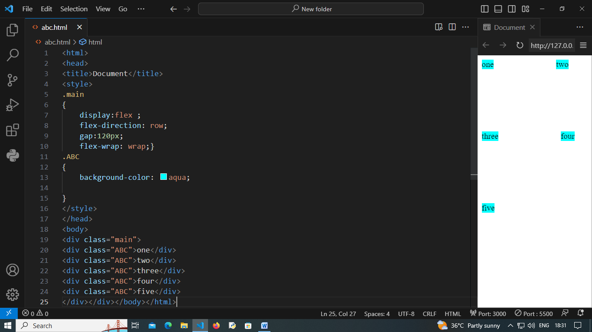
<!DOCTYPE html>
<html lang="en">
<head>
<style>
#pa
{
border: 5px solid red;
background-color: aqua;
padding: 30px;
display:flex;
/* flex-direction:column-reverse; */
/* flex-wrap: wrap-reverse; */
flex-flow: row wrap;
/* justify-content:right; */
height: 600px;
align-items:end;
align-content: space-between;
}
.a
{
width: 100px;
height: 100px;
border:5px solid;
background-color: #fff;
align-content: center;
}
</style>
</head>
<body>
<div id="pa">
<div class="a"><h2>1</h2></div>
<div class="a"><h2>2</h2></div>
<div class="a"><h2>3</h2></div>
<div class="a"><h2>4</h2></div>
<div class="a"><h2>5</h2></div>
</div>
</body>
</html>

- display:grid;
<!DOCTYPE html>
<html lang="en">
<head>
<title>Document</title>
<style>
.a
{
border: 2px solid black;
background-color: aqua;
display: grid;
grid-template-columns:auto auto auto auto auto;
/* column-gap: 50px;
row-gap: 50px; */
padding: 20px;
gap:50px 50px;
}
.b
{
border: 1px solid red;
background-color: #fff;
width: 100px;
padding: 20px;
text-align: center;
height: 100px;
}
/* .i2
{
grid-column-start: 1;
grid-column-end: 3;
} */
.i2
{
grid-column-start: 3;
grid-column-end: 1;
}
</style>
</head>
<body>
<div class="a">
<div class="b i1">1</div>
<div class="b i2">2</div>
<div class="b i3">3</div>
<div class="b i4">4</div>
<div class="b i5">5</div>
<div class="b i6">6</div>
</div>
</body>
</html>

Fafa icon and fafa link:
- https://fontawesome.com/v4/icons/
- fafa cdn link Content Deliver Network
- Syntax:
<link rel="stylesheet" href="https://cdnjs.cloudflare.com/ajax/libs/font-awesome/4.7.0/css/font-awesome.min.css">
<!DOCTYPE html>
<html lang="en">
<head>
<meta charset="UTF-8">
<meta name="viewport" content="width=device-width, initial-scale=1.0">
<title>Document</title>
<link rel="stylesheet" href="https://cdnjs.cloudflare.com/ajax/libs/font-awesome/4.7.0/css/font-awesome.min.css">
<style>
#a
{
font-size: 100px;
}
</style>
</head>
<body>
<i class="fa fa-address-book" id="a"></i>
</body>
</html>

CSS Responsive Web Design:
- Media Query
- Media query is a CSS technique introduced in CSS3.
- It uses the @media rule to include a block of CSS properties only if a certain condition is true.
- Syntax:
@media not|only mediatype and (media feature) and (media feature)
{
CSS-Code;
}
<!DOCTYPE html>
<html lang="en">
<head>
<meta charset="UTF-8">
<meta name="viewport" content="width=device-width, initial-scale=1.0">
<title>Document</title>
<style>
/* h1
{
background-color: purple;
color: pink;
} */
/* Mobile view */
@media screen and (max-width:767px)
{
h1
{
background-color: red;
color: yellow;
}
}
/* Tablet view */
@media screen and (min-width:768px) and (max-width:991px)
{
h1
{
background-color:crimson;
color:aqua;
}
}
/* Laptop view */
@media screen and(min-width:992px) and (max-width:1199px)
{
h1
{
background-color:darkgray;
color:white;
}
}
/* Desktop view */
@media screen and (min-width: 1200px)
{
h1
{
background-color: black;
color: lightgray;
}
}
</style>
</head>
<body>
<h1>Yoga</h1>
</body>
</html>
CSS Position:
5 types
- Static By default, we cannot apply left,right,top,bottom property
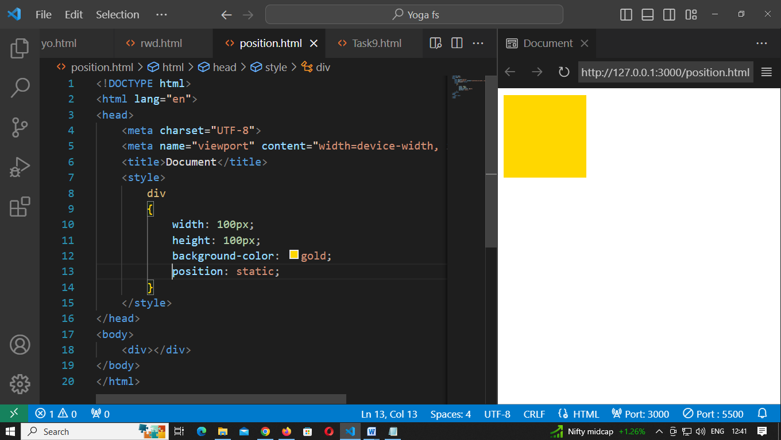
- Relative adjusting purpose (top,bottom) (left,right)
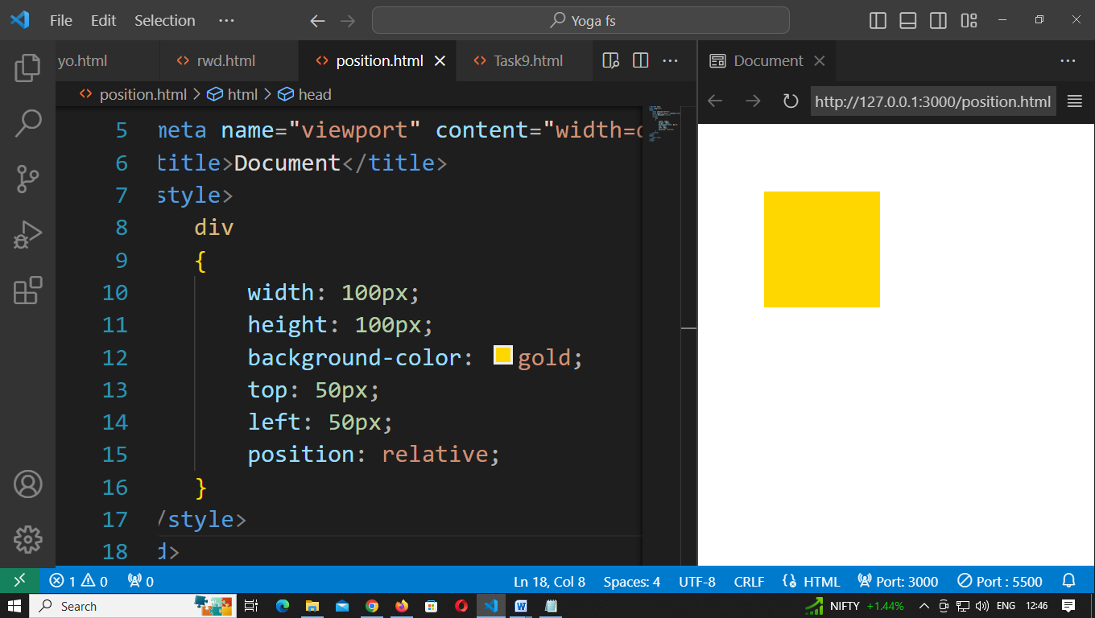
- Fixed always stays in the same place, if the page is scrolled
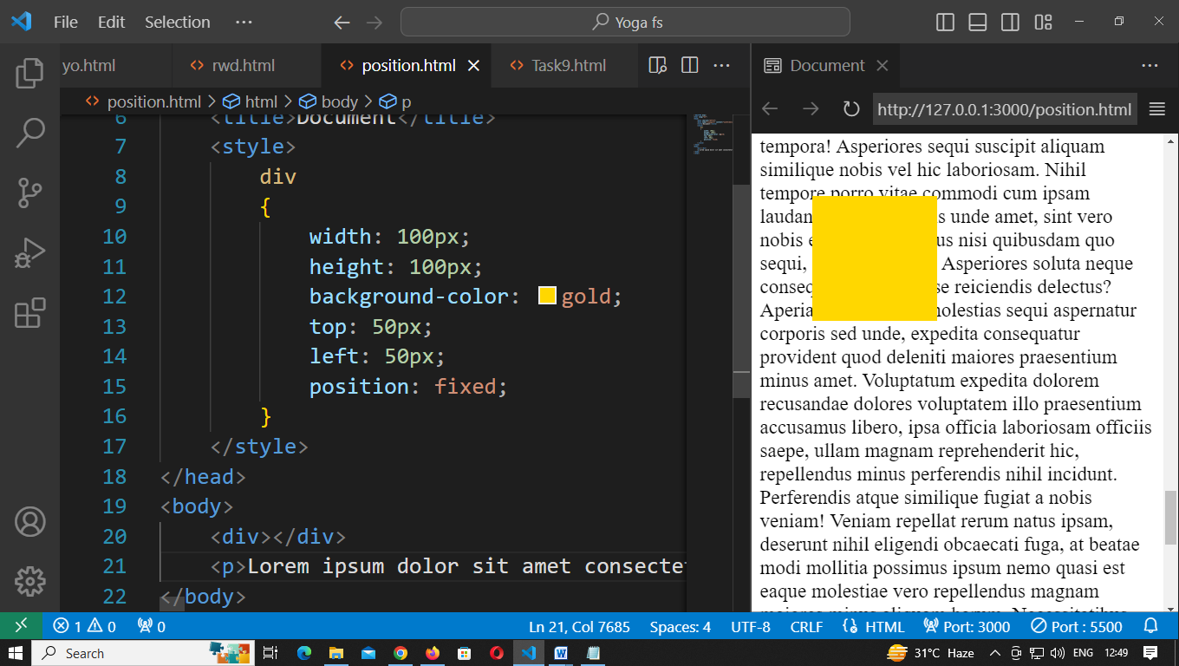
- Absolute It is positioned relative to the nearest positioned ancestor(parent)
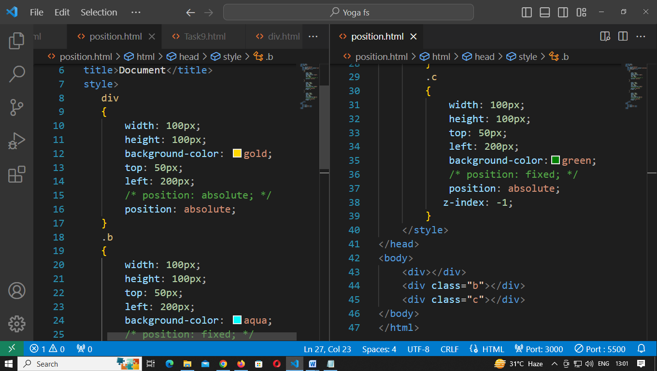
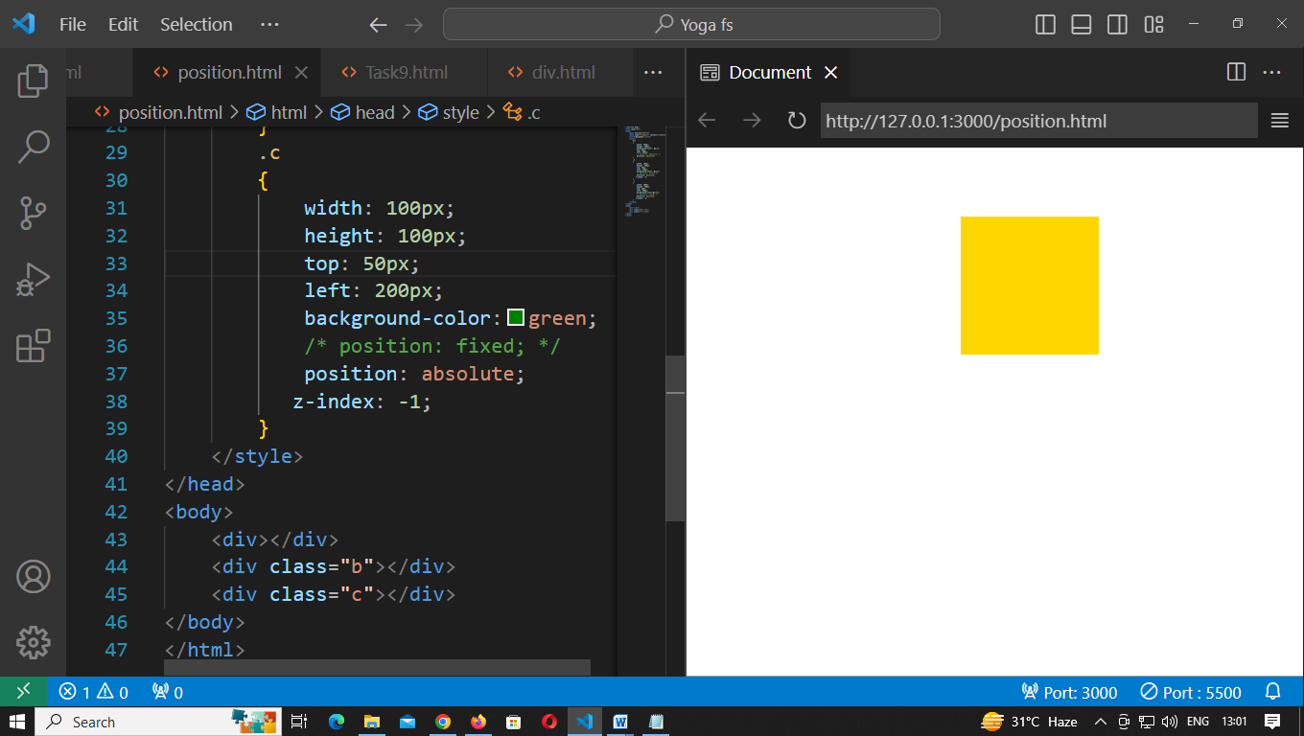
- Sticky it is based on the users scroll position
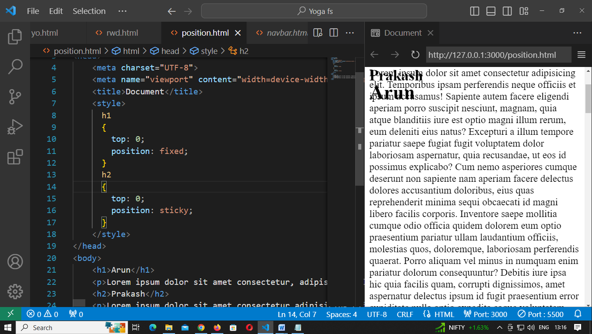

CSS Layout - The z-index Property:
- It specifies the stack order of an element.
- When elements are positioned, they can overlap other elements.
- The z-index property specifies the stack order of an element (which element should be placed in front of, or behind, the others).
- An element can have a positive or negative stack order.
- It only works on positioned elements (position: absolute, position: relative, position: fixed, or position: sticky) and flex items.

CSS Layout – Overflow:
- It specifies whether to clip the content or to add scrollbars when the content of an element is too big to fit in the specified area.
- Overflow properties:
  - visible - Default. The overflow is not clipped. The content renders outside the element's box
  - hidden - The overflow is clipped, and the rest of the content will be invisible
  - scroll - The overflow is clipped, and a scrollbar is added to see the rest of the content
  - auto - Similar to scroll, but it adds scrollbars only when necessary.
<!DOCTYPE html>
<html>
<head>
<style>
div {
background-color: coral;
width: 200px;
height: 65px;
border: 1px solid;
overflow: scroll;
}
</style>
</head>
<body>
<div>Lorem ipsum, dolor sit amet consectetur adipisicing elit. Ea tempore atque non distinctio autem iste, cumque porro recusandae dolorem consequatur.</div>
</body>
</html>
CSS Animations:
- It allows animations of html elements without using Javascript or Flash!
- In this element gradually change from one style to another.
- To use css animation, we must first specify some keyframes.
Properties:
- @keyframes it will gradually change from the current style to the new style
- animation-name
- animation-durationhow long an animation should take to completedefault value 0s
- animation-delay
- animation-iteration-count
- animation-direction
- animation-timing-function
- animation-fill-mode
- animation-play-state
- animation
Ex1: Square shape animation
<!DOCTYPE html>
<html lang="en">
<head>
<title>Document</title>
<style>
div
{
width: 100px;
height: 100px;
background-color: aqua;
animation-name: y;
animation-duration: 4s;
}
@keyframes y
{
from /* 0% */
{
background-color:aqua;
}
to /* 100% */
{
background-color: chartreuse;
}
}
</style>
</head>
<body>
<div></div>
</body>
</html>

Ex2: Ball shape animation
<!DOCTYPE html>
<html lang="en">
<head>
<title>Document</title>
<style>
div
{
width: 100px;
height: 100px;
border-radius: 50%;
background-color: aqua;
animation-name: y;
animation-duration: 4s;
animation-iteration-count: infinite;
}
@keyframes y
{
0%
{
background-color: aqua;
}
25%
{
background-color: yellow;
}
50%
{
background-color: red;
}
100%
{
background-color: violet;
}
}
</style>
</head>
<body>
<div></div>
</body>
</html>

Ex3: Ball move(absolute)
<!DOCTYPE html>
<html lang="en">
<head>
<title>Document</title>
<style>
.a
{
background-color: red;
left: 10px;
top: 10px;
padding: 50px;
position:absolute;
border-radius: 50%;
animation-name: ball;
animation-duration: 4s;
animation-iteration-count: infinite;
box-shadow: -5px -5px 6px black;
}
@keyframes ball
{
0%
{
box-shadow: -5px -5px 5px black;
}
25%
{
background-color: yellow;
left: 150px;
top: 10px;
}
50%
{
background-color: green;
left: 150px;
top: 150px;
}
75%
{
left: 10px;
top: 150px;
background-color: blue;
}
}
</style>
</head>
<body>
<div class="a"></div>
</body>
</html>

Ex4: Egg rotatez
<!DOCTYPE html>
<html lang="en">
<head>
<meta charset="UTF-8">
<meta name="viewport" content="width=device-width, initial-scale=1.0">
<title>Document</title>
<style>
.egg{
width: 100px;
height: 130px;
background-color: rgb(14, 61, 248);
border-radius: 50% /80px 80px 50px 50px;
position: absolute;
left: 10px;
animation-name: egg;
animation-duration: 2s;
animation-iteration-count: infinite;
}

@keyframes egg
{

50%{
left: 150px;
transform:rotatez(720deg);
/* transform: scale(1.2); */ zoom
}
}
</style>
</head>
<body>
<div class="egg"></div>
</body>
</html>

Ex5: Image animation
<!DOCTYPE html>
<html lang="en">
<head>
<meta charset="UTF-8">
<meta name="viewport" content="width=device-width, initial-scale=1.0">
<title>Document</title>
<style>
#a
{
animation-name: D;
animation-duration: 2s;
animation-iteration-count: infinite;
}
@keyframes D
{
50%
{
left:500px;
transform: rotateZ(9deg);
}
}
#b
{
animation-name: eg;
animation-duration: 2s;
animation-iteration-count: infinite;
}
@keyframes eg
{
50%
{
left:500px;
transform: rotateZ(9deg);
}
}
</style>
</head>
<body>
<img id="a" src="Dhoni.jpg" alt="" width="90px" height="90px">
<img id="b" src="Dhoni.jpg" alt="" width="90px" height="90px">
</body>
</html>

<!DOCTYPE html>
<html lang="en">
<head>
<meta charset="UTF-8">
<meta name="viewport" content="width=device-width, initial-scale=1.0">
<title>Document</title>
<style>
div
{
width: 100px;
height: 100px;
background-color: aqua;
animation: y 10s linear 1s infinite alternate backwards;
/* animation: name duration timing-function delay iteration-count direction fill-mode; */
position: relative;

}
div:hover
{
animation-play-state: paused;
}
@keyframes y
{
50%
{
left: 200px;
background-color: orangered;
}
}
</style>
</head>
<body>
<div></div>
</body>
</html>
CSS Float:
- The float property specifies whether an element should float to the left, right, or not at all.
- Absolutely positioned elements ignore the float property!
- Elements next to a floating element will flow around it.
- To avoid this, use the clear property or the clearfix hack (see example at the bottom of this page).
<!DOCTYPE html>
<html>
<head>
<style>
img
{
float: left;
}
</style>
</head>
<body>
<p>The image will float to the left in the text, and the text in the paragraph will wrap around the image.</p>
<p>
<img src="pineapple.jpg" alt="Pineapple">
Lorem ipsum dolor sit amet, consectetur adipiscing elit. Phasellus imperdiet, nulla et dictum interdum,
nisi lorem egestas odio, vitae scelerisque enim ligula venenatis dolor. Maecenas nisl est, ultrices nec congue eget,
auctor vitae massa. Fusce luctus vestibulum augue ut aliquet. Mauris ante ligula, facilisis sed ornare eu, lobortis
in odio. Praesent convallis urna a lacus interdum ut hendrerit risus congue. Nunc sagittis dictum nisi, sed ullamcorper
ipsum dignissim ac. In at libero sed nunc venenatis imperdiet sed ornare turpis. Donec vitae dui eget tellus gravida
venenatis. Integer fringilla congue eros non fermentum. Sed dapibus pulvinar nibh tempor porta. Cras ac leo purus.
Mauris quis diam velit.
</p>
</body>
</html>

CSS Opacity / Transparency:
- It take a value from 0.0 - 1.0. The lower the value, the more transparent.
<!DOCTYPE html>
<html lang="en">
<head>
<meta charset="UTF-8">
<meta name="viewport" content="width=device-width, initial-scale=1.0">
<title>Document</title>
<style>
div
{
opacity: 0.5;
}
</style>
</head>
<body>
<div> <img src="ajith.jpg" alt=""></div>
</body>
</html>

CSS background-blend-mode: photoshop
- It is used to defined as a value and they specify how to blend or mix the colors of the background image with the color, or other background images, behind it.
<!DOCTYPE html>
<html lang="en">
<head>
<meta charset="UTF-8">
<meta name="viewport" content="width=device-width, initial-scale=1.0">
<title>Document</title>
<style>
body
{
background-image: url(ajith.jpg);
background-size: cover;
background-repeat: no-repeat;
background-color: rgb(0, 162, 255);
background-blend-mode:color-burn;
}
</style>
</head>
<body>
<h1>Yoga</h1>
<p>
Lorem ipsum dolor sit amet consectetur adipisicing elit. Dolorem veritatis explicabo commodi odit, iure eum sunt a? Cum minima voluptates impedit saepe odit, dicta quasi architecto officia eos assumenda autem quibusdam unde! Cum possimus ratione quae voluptate iusto laborum, fuga excepturi aut ab nam! Dolorum, expedita quae. Commodi, dolor et.</p>
</body>
</html>

CSS Transform:
- The transform property applies a 2D or 3D transformation to an element. This property allows you to rotate, scale, move, skew, etc., elements.
- Properties:
- Transform-origin
  - It allows you to change the position of transformed elements.
  - 2D transformations can change the x- and y-axis of an element.
  - 3D transformations can also change the z-axis of an element.
- Transform-style
  - It specifies how nested elements are rendered in 3D space.
CSS Transitions:
- CSS transitions allows you to change property values smoothly, over a given duration.
  - transition
  - transition-delay
  - transition-duration
  - transition-property
  - transition-timing-function ease,ease-in,ease-out,linear,ease-in-out,cubic Bezier(n,n,n,n)
<!DOCTYPE html>
<html>
<head>
<style>
div
{
width: 100px;
height: 100px;
background: red;
transition: width 2s, height 2s, transform 2s;
}
div:hover
{
width: 300px;
height: 300px;
transform: rotate(180deg);
}
</style>
</head>
<body>
<div></div>
</body>
</html>

<!DOCTYPE html>
<html lang="en">
<head>
<meta charset="UTF-8">
<meta name="viewport" content="width=device-width, initial-scale=1.0">
<title>Document</title>
<style>
div
{
height: 100px;
width: 100px;
background-color: red;
}
div:hover
{
width: 200px;
height: 200px;
border-radius: 50%;
transition-delay: 3s;
transition-duration:1500ms;
/* transition-property: none; */
transition-timing-function:linear;
box-shadow: 3px 3px 5px blue;
}
</style>
</head>
<body>
<div></div>
</body>
</html>

CSS DropDown:
- To create a dropdown box that appears when the user moves the mouse over an element.
- 4 types in dropdown
- Dropdown menu
<!DOCTYPE html>
<html lang="en">
<head>
<meta charset="UTF-8">
<meta name="viewport" content="width=device-width, initial-scale=1.0">
<title>Document</title>
<style>
.drop
{
position: relative;
}
.down
{
display: none;
position: absolute;
filter: drop-shadow(3px 3px 5px blue);
/* filter: blur(3px); */
filter: brightness(50px);
}
.drop:hover>.down
{
display: block;
}
</style>
</head>
<body>
<div class="drop">
<h1>Mouse hover</h1>
<div class="down">
<h2>Hover me</h2>
</div>
</div>
</body>
</html>
- Right-aligned Dropdown Content
- If you want the dropdown menu to go from right to left, instead of left to right, add right: 0;
- Dropdown Image
- Dropdown navbar
<!DOCTYPE html>
<html lang="en">
<head>
<title>Html</title>
<style>
header
{
background-color: #2F4858;
padding: 10px;
}
nav ul
{
list-style: none;
margin: 0;
padding: 0;
display: flex;
justify-content: space-evenly;
}
li
{
/* display: inline; */
/* margin-right: 20px; */
position: relative;
}
a
{
text-decoration: none;
color: white;
font-weight: bold;
font-size: 26px;
}
a:hover {
color: #F0C50D;
border-bottom: 2px solid #00EDD2;
}
/* Style for the dropdown menu */
nav ul ul {
display: none;
position: absolute;
top: 100%;
left: 0;
background-color: #2F4858;
padding: 10px;
border-radius: 0 0 5px 5px;
box-shadow: 0px 8px 16px 0px rgba(0,0,0,0.2);
}
nav li:hover>ul
{
display: block;
}
</style>
</head>
<body>
<header>
<nav>
<ul>
<li><a href="#">Home</a></li>
<li><a href="#">About</a></li>
<li>
<a href="#">Services</a>
<!-- Dropdown menu for Services -->
<ul>
<li><a href="#">yoga</a></li>
<li><a href="#">ishu</a></li>
<li><a href="#">sankar</a></li>
</ul>
</li>
<li><a href="#">Contact</a></li>
</ul>
</nav>
</header>
</body>
</html>

CSS Pagination:
<!DOCTYPE html>
<html>
<head>
<style>
.p
{
display: inline-block;
}
a {
color: black;
float: left;
padding: 8px 16px;
text-decoration: none;
transition: background-color .3s;
border: 1px solid #ddd;
}
a.active {
background-color: #4CAF50;
color: white;
border: 1px solid #4CAF50;
}
a:hover:not(.active)
{
background-color:lightgray;
}
</style>
</head>
<body>
<div class="p">
<a href="#">&laquo;</a>
<a href="#">1</a>
<a href="#" class="active">2</a>
<a href="#">3</a>
<a href="#">4</a>
<a href="#">5</a>
<a href="#">6</a>
<a href="#">&raquo;</a>
</div>
</body>
</html>

